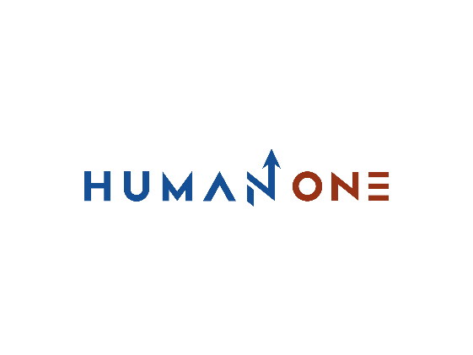

Services

Big data & Analytics

Expertise

**EN**

**FR**

Get in touch

Company

# **Big data & Analytics**



At HumanOne, we leverage advanced big data and business intelligence tools to help clients extract actionable insights from diverse data sets generated in real time and at a large scale. We enable organizations to consolidate massive volumes of structured, semi-structured, and unstructured data coming from different sources into a holistic environment that can be used for modelling and predicting new market opportunities.

Let’s Talk



HumanOne experts offer a full range of big data services, from consulting and strategy definition to infrastructure maintenance and support, enabling our clients to get vital insights from previously untapped data assets. We apply a proprietary big data framework combined with popular open-source technologies like Apache Hadoop, Spark, and Kafka as well as machine learning and deep learning algorithms to deliver a comprehensive tool set for storing, processing, and analyzing large quantities of data.

**Big data consulting**

Leverage our Big Data consulting services to evaluate and optimize your current Big Data solution, define a product strategy, and identify the most appropriate technologies that will help you turn your data into revenue opportunities.



**Data infrastructure & engineering**

Create data warehouse and data lake solutions, and streamline ETL development, execution, and management tasks by creating data pipelines that transform raw data into organized data sets that can be easily retrieved for further processing.

**Data visualization**

Gain 360-degree visibility into your data with interactive reports and intuitive dashboards that make analysis understandable and manageable for everyone at every level of your organization.

**BI & data analytics**

Make better decisions faster by accelerating your time to insight with revolutionary business intelligence tools and leveraging a data science approach that includes statistical and machine learning techniques.



**Data security**

Protect your data from intentional and accidental destruction, modification, or disclosure by adhering to security standards, developing a tiered access system, and ensuring effective backup and recovery processes.

**Data monetization**

Integrate analytics into your products and services to reveal insights that improve overall business performance, strengthen customer loyalty, and help you identify new growth opportunities.

Uncover operational insights from previously untapped data sources

Get in touch



**Additional benefits of working with HumanOne**



Extensive AI skill set for accurate predictions based on data modelling

Big Data Center of Excellence with leading experts to conquer the most challenging tasks



Top-tier UI/UX expertise to present complex data to users in a visually appealing manner

Profound cloud competency covering the AWS, Microsoft Azure, and Google Cloud platforms

**Our approach**

1

5

3

**Incorporate in business**

**Prepare data**

**Define the problem**

Integrate analytical algorithms into your production environment to unlock new opportunities

Evaluate data quality and remove inaccurate records to structure data for further analysis.

Assess your business environment and performance to identify key goals and challenges

6

4

2

Continuously assess the performance of your algorithms and make adjustments if necessary

**Validate the results**

**Analyze data**

**Collect data**

Develop analytical algorithms to discover useful insights for making business decisions

Gather data in different formats from multiple sources to address identified goals



